

10 P’s of Marketing
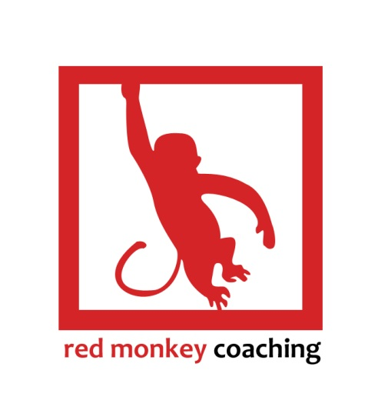
Workbook

Copyright © Red Monkey Coaching 2018

This document was created by Red Monkey Coaching and is subject to copyright. No part may be reproduced by any process without prior written permission.

Copyright © Red Monkey Coaching 2013

This document was created by Red Monkey Coaching and is subject to copyright and no part may be reproduced by any process without prior written permission.

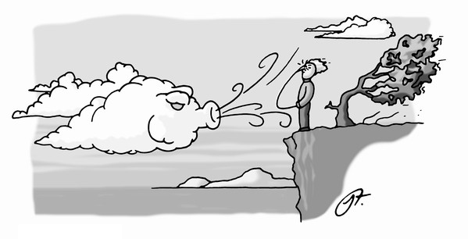
Does spending your marketing $$$ feel like this...
Join us to learn about the REAL P’s of marketing.

Are you worried that this might be the same old story, or that you’ve heard it all before? Don’t worry, you’ll be pleased you didn’t miss this!

What is this workbook all about?

- You’ll learn all about the 10 P’s of marketing for your business.
- You’ll learn interesting ways to add real value to your bottom line.
- You’ll discover how to thrive & not just survive in any market.
- You’ll learn some of the secrets that have allowed our clients to increase turnover and retained profit.
- And we guarantee you will walk away with a quick, easy and simple plan to make it happen!
- Oh, and we also guarantee you’ll have some fun in the process.

- Premises

Have business premises.
Sounds like we are stating the obvious but your customers need to be able to recognise what your business is and what service and products you offer.


How your premises look is a good indicator of how you feel about your business.

* Rate the appearance of your premises. /10

* List 5 ways to improve.

- Purpose

A successful business owner needs to know exactly why they are in business.

Consider:

- What is your major purpose?
- What are your short and long term goals?
- What is your exit strategy?
What is Your Purpose?
Let’s look at the elements of your purpose in business.
Purpose
Skills
Talents
Passion
Abilities

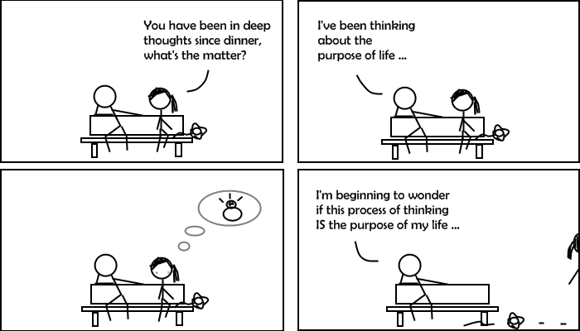
- Position

What’s your Position?

Where are you positioned in the marketplace? Have you given adequate thought to your:

- Demographic
- Competition
- Uniqueness


Notes
- Person

Do you know what your ideal customer looks like?

Let’s draw them.



- Product

We have all heard about the importance of product knowledge. Understanding what your customers want to buy is as important as knowing what it is you are selling.

Marketing the right product, the right way is vital.



- Plan

Marketing, like everything in business, needs a plan. At the end of this session, you will have a one page marketing strategy.

Remember, a fail to plan is a plan to fail!

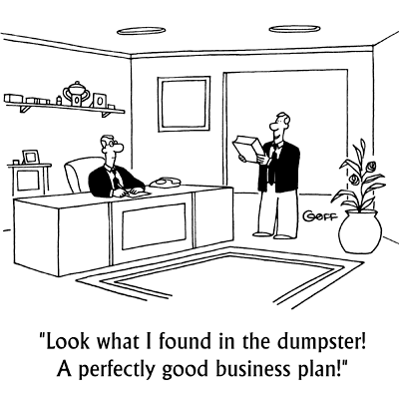

- Promotion

To creatively and successfully market your business we need to understand the basics of promotion.

You will also benefit from understanding some guerrilla promotion as well.

The ten ways I can improve my promotion.

1.
2.
3.
4.
5.

6.
7.
8.
9.
10.
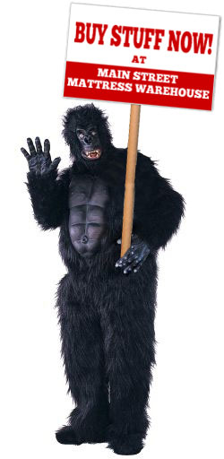

- Profit


We are all in business to make a profit. It should have been one of your purpose items!

What are the ways that you make a profit?

- Pricing

Understanding pricing is vital.
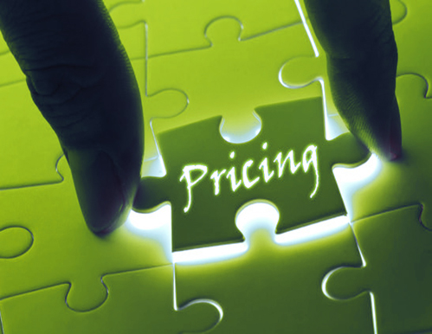
You will need to know:

- Price points
- Price barriers
- Price objections

- Program

Once your marketing plan is complete, you need a program to implement the strategies.

You also need to know who you can enlist to help and you can delegate to.

Notes
10 P’s Planning

Marketing Theme:
P: | CATEGORY: | STRATEGY:
PREMISES | What I will do to improve:
PURPOSE | My reason for existence:
POSITION | What sets my business apart from the rest:
PERSON | My ideal customer is:
PRODUCT | What’s most important to my ideal customer when they are buying what I am selling:
PLAN | What I want to accomplish this year:
PROMOTION | What will trigger my ideal customer to think of me & the top 3 things that are going to get me there:
PROFIT | How much will each program contribute to my revenue/ profitability:
PRICING | How much money will I need to get it done:
PROGRAM | Programs I am running to reach my goal:

